Module 8: Final Project

Nathan Rogers
Colorado State University Global
Course Code: CSC505
Dr. Luis Gonzalez
04/06/2025

Assignment
For your final project, you are going to create a UML diagram of your choice (e.g., Sequence, Class, Activity, etc.) for an automated teller machine (ATM). Your diagram should include the following:
- The customer must pass authentication before withdrawing money.
- Authentication is performed by checking a PIN.
- The PIN can be correct or not.
- Unsuccessful attempts are counted.
- If the counter exceeds a limit, then the customer is rejected.
- If the account balance is zero, then the account is closed.

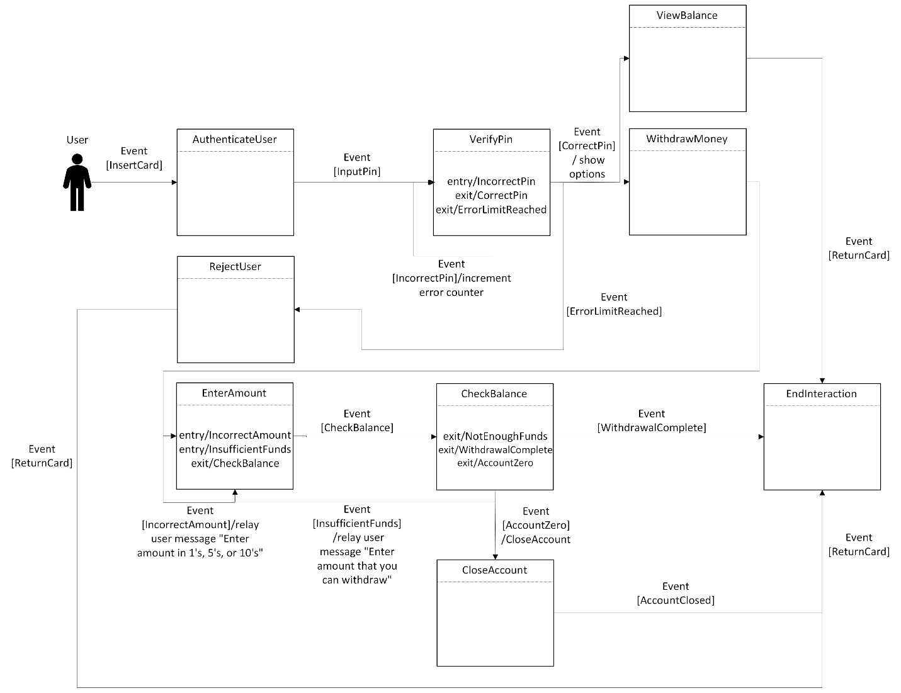
Write a Python Script that will print all the steps in sequence for all the operations at the teller machine as shown in your diagram(s)

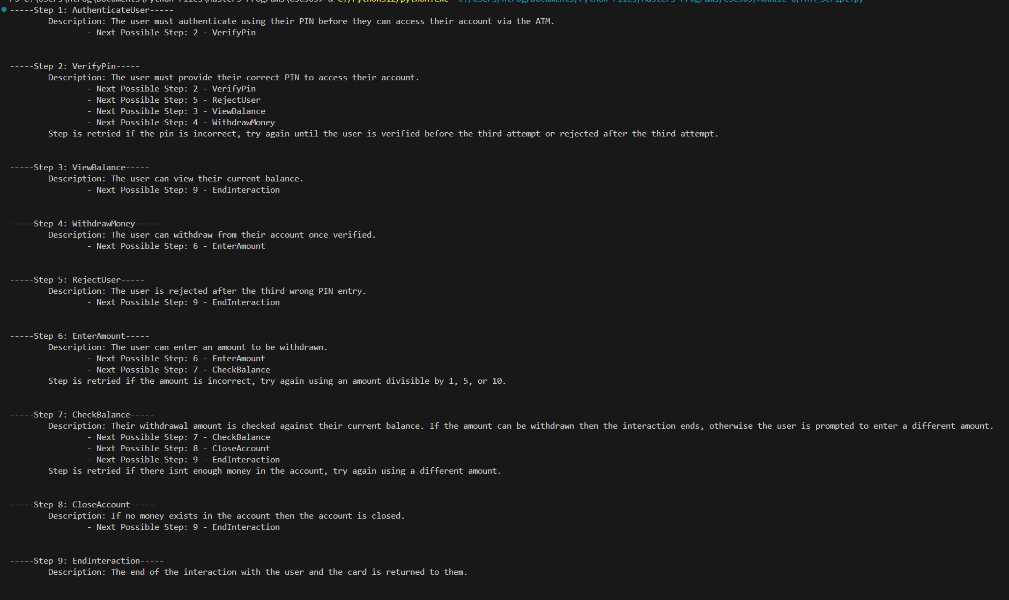

Analysis
In the UML above, it can be observed that a sequence diagram was used to depict the ATM events. The sequence shows the interaction between the user, ATM and bank verifications and what major events occur while trying to use an ATM. Beyond this sequence diagram there are certain considerations that need to be explored. We can look at a system use case scenario to understand some additions that could be made to the UML above.
Primary Actors: User, ATM
Goal In Context: To withdraw money from the user’s bank account using an ATM.
Preconditions:
- The ATM is functioning normally
- The ATM has money to distribute to the user
- Authentication servers at the bank are functioning normally
- The user’s bank card functions normally and can be read in the ATM
- The user’s account exists and has money to be withdrawn
Trigger: User inserts their bank card into the ATM
Scenario:
- User enters their PIN into the ATM
- The user’s PIN is authenticated and is correct
- User selects the withdraw option
- User enters an amount to be withdrawn from their account
- User is given back their card and the money is correctly distributed to the user

Exceptions:
- The wrong card is inserted into the ATM and the ATM cannot read the card
- The wrong card is inserted into the ATM and the user is charged a fee for using the wrong ATM
- The authentication servers are not working, and the ATM cannot be used
- The ATM is closed due to maintenance and is unusable
- The ATM does not have any money to distribute to users
- The user inputs the wrong PIN
- The ATM does not return the card to the user
- The ATM does not correctly distribute the right amount of money to the user
- The user’s account has a zero balance and has been closed in which case the user cannot withdraw money
- The user has exceeded the number of attempts to access their account with the wrong PIN and they have been locked out
- The number keypad on the ATM is not functioning and the correct PIN cannot be entered
- The button to select withdrawal is not functioning so the user cannot proceed with their withdrawal
Priority: Essential, must be implemented
When Available: 24/7 for users to access the ATM when needed
Frequency of use: Can be used several times a day by many people or not at all.
Channel to actor: Local bank branch or wherever the ATM is offered
Secondary actors: Secure Network, Bank
Channels to secondary actors: Internet access
When comparing the system use case scenario to the sequence UML diagram we can see a lot of overlaps. However, the system use case considers and includes more details than the major events that the sequence diagram considers. Considerations such as the physical condition of the ATM and the user’s card and whether the user can access their account under normal circumstances. There are also conditions that do not exist in either explanation such as edge cases. We can ask questions like “What happens if a customer enters the wrong PIN, but the account balance is already 0? Should they still be prompted to retry?”, “What feedback is provided to customers during failed authentications or account closures?” and “If the authentication server times out should this count as a failed attempt even if the correct PIN was entered?”. I believe all these questions should be considered to ensure that there is a positive user experience using this system. Even though this system is not an application on a mobile device or desktop there should be user experience considerations made with prompts and user interface screens. If the user interface or prompts are confusing or misleading, then the user could get frustrated and could lead to having their account locked or choosing the wrong option.
Real World Considerations
Analyzing the above sequence diagram requirements, we can see that there are inconsistencies with what actually occurs in real world cases. Let’s look a look at the automatic account closure when the balance equals zero. Unless this is a specific bank case, the usual event that occurs is the account is allowed to remain open, but a fee might occur for having a balance under a certain amount. There would also be overdraft protections in place if the user tries to withdraw more than their account has in it. I do believe account locking is a standard banking practice that when accessing an ATM if the wrong PIN is entered three or more times. The user’s account is then temporarily locked, and the ATM can temporarily confiscate the card in case the card is stolen or being misused.
Another important consideration should be inspecting the ATM for damage or extra hardware that could steal your cards information such as the number and entered PIN. “Criminals may attempt to install skimming devices to capture your card information.” (Essential ATM and ITM Safety Tips 2023). These skimming devices can be installed on POS checkout terminals and ATMs. To combat these and increase user trust and safety, banks have started to put safety stickers on anything that can detach from or open on the ATM. Intact or broken stickers can be easily noticed and is a quick inspection step upon walking up to the ATM. Considering the above diagrams and cases, inspecting the ATM should be an additional step included in the beginning steps. On the same safety consideration, there should be additional steps for general safety of the user and user’s information such as covering the keypad when entering the PIN and immediately putting your card, money, and receipt away to prevent theft opportunities.

References
Pressman, R. S., & Maxim, B. R. (2020). Software engineering: A practitioner’s approach. McGraw-Hill Education.
What is an edge case? definition and examples in a product. What Is an Edge Case? Definition and Examples in a Product. (n.d.). https://airfocus.com/glossary/what-is-an-edge-case/
Credit Human. (2023, September 13). Essential ATM and ITM Safety Tips. Credit Human. https://www.credithuman.com/building-slack/essential-atm-and-itm-safety-tips

